**Professional Behavior Template Example**

1. **Interacting Professionally with the Instructor:**My interaction with you throughout this course has been fairly minimal, but I did my best to try and be civil, professional, and formal in my writing to you. As an example, here’s an excerpt of the last email I submitted to you: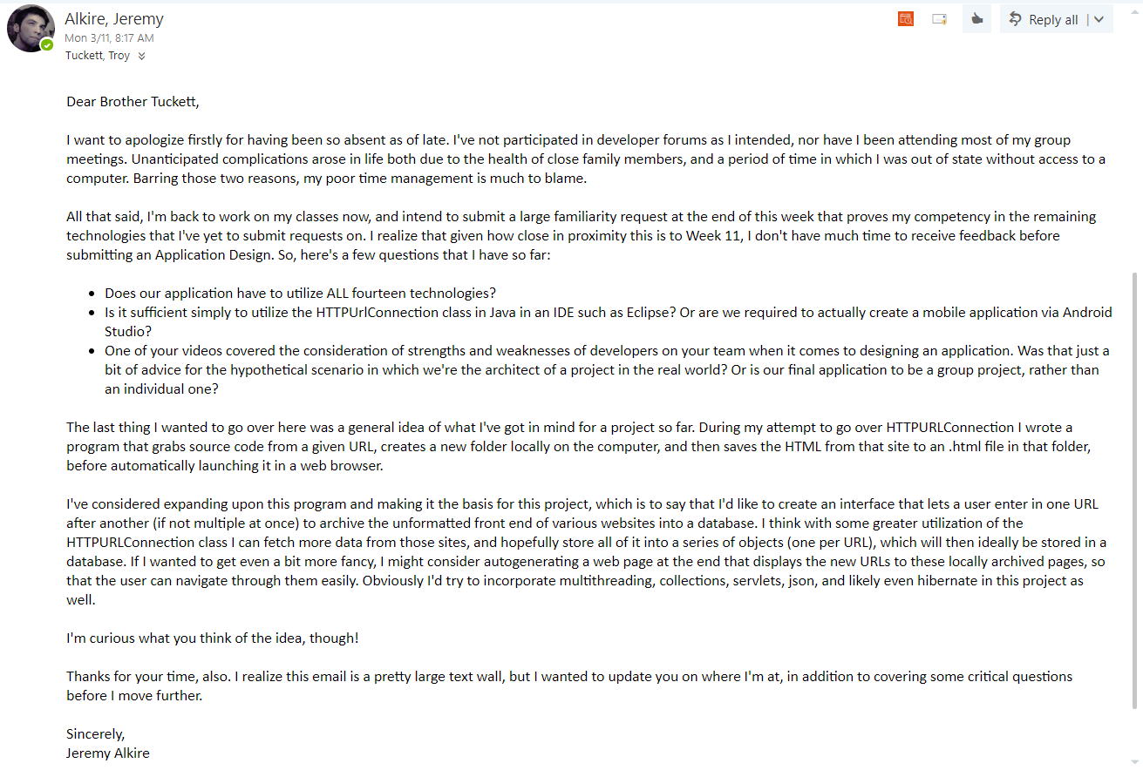
2. **Interacting Helpfully and Professionally with Other Teams:**I’ve not interacted nearly as much with my classmates in this course as I should have. Much of this was due to schedule compatibility issues. Often times my erratic sleeping schedule coupled with my gym schedule caused conflict with my group meeting times. I’ve hardly participated in the developer forum at all. In this manner, I’ve done very poorly, and sorely regret it.
3. **Supporting the Team by Teaching, etc.**I’ve not done anything additional to teach other students since my last familiarity request. Although, if I’m permitted to work on a final project, I can certainly create a video that comprehensively reviews some of the technologies we’ve worked on, and adds additional design tips (or reviews of different design patterns) to assist them in their projects.
4. **Self-Reflection/Meta-Cognition:**There’s much to reflect on this semester, for me. A large part of my issue has stemmed from poor time management coupled with a poor sleeping schedule. I could go into great detail about this, but in short – I can and need to do much better in the future.  
     
   Regarding this course: I’m perfectly comfortable with programming, and sincerely have looked forwards to the final project. My greatest struggle was environment set up, coupled with a slew of issues that stemmed from Tomcat not deploying class updates properly. But I eventually figured it all out, and everything works as intended now!
5. **Team's Agile Methodology:**Our team chose the scrum methodology. Though we don’t meet via video daily, we do chat daily in our hangouts group. I’ve not participated in these group chats as much as I should have.
6. **Professional Scheduling Group:**To my knowledge we don’t have a specific schedule regarding teaching topics. As it was told to me, when we meet, whoever teaches is dependent upon who knows a certain subject, and what they feel comfortable with teaching at that time. We try to meet by Wednesday each week.  
     
   I’ve missed most of these meetings.